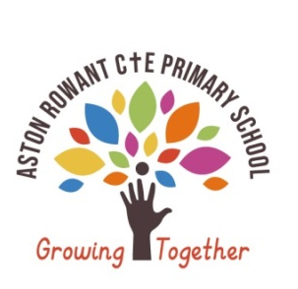
-Aston Rowant C†E Primary School
Growing together we inspire each other to achieve our full potential as courageous life long learners.
English Long Term Plan Squirrel Class 2025-26
The goal of education in Aston Rowant C†E Primary School is to enable our children be curious in their approach to learning, to be courageous in their attitude to learning, to be empowered to work both independently and collaboratively, to understand the impact their learning has had on them so far and be inspired to keep learning.
Year 1/2 CYCLE B
AUTUMN 1 |  | SPRING 1 |  | SUMMER 1
What Makes Me, Me (2025-26) |  | A Sense of Belonging (2025-26) |  | Window on the World (2025-26)
Learning journey Autumn |  | Learning journey Spring |  | Learning journey Summer
Writing Text  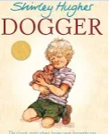  Outcome: (Stories on a theme) Narrative – Simple sentences/labels/Lost! Poster, Retell Y2)  Reading / Parallel Text  Dogger’s Christmas | Writing Text  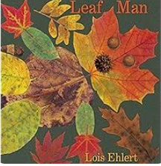  Outcome: (Stories on a theme) Narrative – Retell)  Children will learn and perform this poem before adapting it to make it their own.  Reading / Parallel Text  Bonfire Poetry (Safety Instructions) | Writing Text    Outcome: (Adventure stories) Write in role as Traction Man  Plan an adventure story innovation in comic style.  Reading / Parallel Text  Traction Man meets Turbo dog | Writing Text  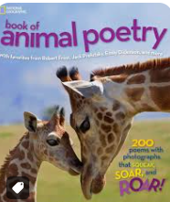  Outcome: (Poems to perform Y1 and writing own poems Y2)  Reading / Parallel Text  Cloud Soup by Kate Wakeling | Writing Text  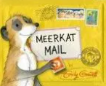  Outcome: (Letter Writing -grammar focus ?! and diary entries)  Reading / Parallel Text  At the Crossroads by Rachel Isadora | Writing Text  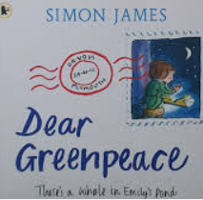  Outcome: (non-chronological reports on sea creatures, postcards)  Reading / Parallel Text  One Plastic Bag by Miranda Paul  Let’s investigate Plastic Pollution (Ruth Owen)
Writing Text  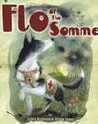  Outcome: (Diary entries in role, thought bubbles)  Reading / Parallel Text  Where the Poppies Now Grow  Stubby: The Hero Dog | Writing Text  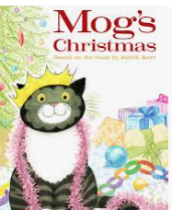  Outcome: Descriptive writing in role as a character, simple retell & imitation of story)  Reading / Parallel Text  Mog’s Christmas Calamity (Visual literacy link) | Writing Text  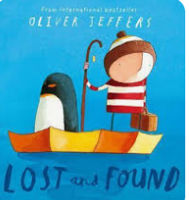  Outcome: Descriptive writing in role as a character.  Reading / Parallel Text  Way Back Home by Oliver Jeffers | Writing Text  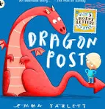  Outcome: (Instruction writing, planning questions)  Reading / Parallel Text  Amos and Boris by William Steig | Writing Text  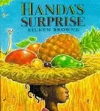  Outcome: (Narrative – story retell Y1/innovation Y2 with grammar focus on speech & instruction writing with time adverbials for fruit kebab DT link)  Reading / Parallel Text  The Ugly Five by Julia Donaldson | Writing Text  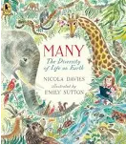  Outcome: (Information texts and recount of trip to Beale Park to see animals)  Reading / Parallel Text  Greta Thunberg (Little People Big Dreams)  Captain Green and the Plastic Scene by Evelyn Bookless
Year 1  spell words containing each of the  40+ phonemes already taught  Spell common exception words  leave spaces between words  write simple labels and captions  compose a sentence orally before writing it  use personal pronoun I  begin to form lower-case letters in the correct direction, starting and  finishing in the right place  Year 2  consider what they are going to write before beginning by planning or saying out loud and writing down ideas and/or key words, including new vocabulary  use capital letters and full stops to punctuate a sentence  start using some of the diagonal and horizontal strokes needed to join letters  write simple noun phrases to describe and specify  use coordinating conjunctions(or / and / but / so)  reread what has been written to check it makes sense spell common exception words | Year 1  consider what they are going to write before beginning by writing down ideas and/or key words, including new vocabulary use simple word choice that helps to convey information and ideas, e.g. story or topic related vocabulary  spell words using known phonemes  use simple noun phrases (adjective + noun)  sequence sentences to form short narratives  evaluating their writing with the teacher and other pupils  proof-read to check for errors in spelling  punctuate sentences using a capital  letter and a full stop  Year 2  start using some of the diagonal and horizontal strokes needed to join letters and understand which letters, when adjacent to one another, are best left not joined.  consider what they are going to write before beginning by writing down ideas and/or key words,  including new vocabulary  proof-read to check for errors in  spelling, grammar and punctuation  use sentences with different forms: question, exclamation, commands  use coordinating conjunctions  (or/and/but/so)  learn how to use subordination (using when, if, that, or because)  write expanded noun phrases to  describe and specify  re-read to check that their writing makes sense and that verbs to indicate time are used correctly and consistently, | Year 1  compose a sentence orally before writing it  sequence sentences to form short narratives  use the prefix un  use –ing, –ed, where no change is  needed in the spelling of root words  use simple word choice that helps to convey information and ideas, e.g. story or topic related vocabulary  punctuate sentences using a capital letter and a full stop, question mark  or exclamation mark  use simple noun phrases (adjective + noun)  reread what I have written to check it makes sense  Year 2  use the present and past tenses  correctly and consistently  consider what they are going to write before beginning by encapsulating what they want to say, sentence by sentence  use both familiar and new punctuation correctly including full stops, capital letters, exclamation marks, question marks, commas for lists and apostrophes for contracted  forms and the possessive (singular)  add suffixes to spell longer words  use subordination (using when, if, that, or because)  use some of the diagonal and horizontal strokes needed to join letters and understand which letters, when adjacent to one another, are best left unjoined  to use sentences with different forms:  statement, question, exclamation, command | Year 1  spell the days of the week  sequence sentences to form short narratives  join words/clauses using and  use a capital letter for names of people, places, the days of the  week, and the personal pronoun ‘I’  use simple noun phrases (adjective  + noun)  use-er–est where no change is  needed in the spelling of root  words  punctuate sentences using a capital letter and a full stop, question mark  or exclamation mark  reread what I have written to check it makes sense  Year 2  make simple additions, revisions and corrections to their own writing by proof-reading to check for errors in spelling, grammar and punctuation  add suffixes to spell longer words  use the present and past tenses correctly and consistently including the progressive form  spell more words with contracted forms  consider what they are going to write before beginning by planning or saying out loud what they are going to write about  use subordination (using when, if, that, or because) and co-ordination  (using or, and, or but)  use both familiar and new punctuation correctly, including full stops, capital letters, exclamation marks, question marks, commas for  lists and apostrophes for contracted forms and the possessive (singular) | Year 1  write sentences by saying out loud  what they are going to write about  sequence sentences to form short narratives  use simple word choice that helps to convey information and ideas, e.g. story or topic related vocabulary  use coordinating conjunctions and/but  /so  punctuate sentences using a capital letter and a full stop, question mark  or exclamation mark  using a capital letter for names of people, places, the days of the week, and the personal pronoun ‘I’  discuss what they have written with the teacher or other pupils  Year 2  consider what they are going to write before beginning by planning or saying out loud what they are going to write about  writing down ideas and/or key words, including new vocabulary  use commas for lists  use coordination and subordination  use expanded noun phrases to  describe and specify  to use sentences with different forms:  statement, question, exclamation, command  the present and past tenses correctly and consistently including the progressive form  re-reading to check that their writing makes sense and that verbs to indicate time are used correctly and consistently, including verbs in the  continuous form  make simple additions, revisions and corrections to their own writing by evaluating their writing with the teacher and other pupils | Year 1  use simple word choice that helps to convey information and ideas, e.g. story or topic related  vocabulary  use a capital letter for names of people, places, the days of the  week, and the personal pronoun ‘I’  punctuate sentences using a capital  letter and a full stop, question  mark or exclamation mark  use –ing, –ed, –er and –est where no change is needed in the spelling  of root words  write sentences by saying out loud  what they are going to write about  re-read what they have written to check that it makes sense  Year 2  write down ideas and/or key  words, including new vocabulary  make simple additions, revisions and corrections to their own writing by evaluating their writing with the teacher and other pupils  read aloud what they have written with appropriate intonation to  make the meaning clear  use subordinating conjunctions  (when/ if /that /because)  proof-read to check for errors in spelling, grammar and punctuation  learn to use the apostrophe for singular possession  use commas in a list

